Agentic AI: Intelligent Task Execution System
MAJOR PROJECT REPORT
Submitted in partial fulfillment of the requirement for the Degree of
Bachelors of Engineering in Computer Science & Engineering
Submitted To:

[PARUL UNIVERSITY, VADODARA, GUJARAT (INDIA)]
Submitted By:
Shubham Paithane [2303051051245]
Adarsh Singh Rajput [2303051051092]

Under The Guidance of:
Mr. Meet Kumar Patel
ASSISTANT PROFESSOR
CSE
DEPARTMENT OF COMPUTER SCIENCE & ENGINEERING
PARUL INSTITUTE OF TECHNOLOGY VADODARA, GUJARAT
SESSION: AY 2026-2027

Parul University
Parul Institute of Technology
(Session: 2026 -2027)
DEPARTMENT OF COMPUTER SCIENCE & ENGINEERING
CERTIFICATE
This is to certify that SHUBHAM PAITHANE, ADARSH RAJPUT students of CSE VII Semester of “Parul Institute of Technology, Vadodara” have completed their Major Project titled “Agentic AI – Autonomous Task Execution Assistant (Aizen)”, as per the syllabus and has submitted a satisfactory report on this project as a partial fulfillment towards the award of degree of Bachelor of Technology in Computer Science and Engineering under Parul University, Vadodara, Gujarat (India).

Mr. Meet Kumar Patel  ASSISTANT PROFESSOR  CSE  Project Guide | Ms. Arnika Patel  CSE DEPARTMENT  PIT, Vadodara  Project Coordinator
Dr. Sumitra Menaria  Head (CSE)  PIT, Vadodara  Head of Department | _______________________  External Examiner
Dr. Ruchi Srivastava
PRINCIPAL
PIT, Vadodara
Principal

DECLARATION
We the undersigned solemnly declare that the project report “Agentic AI – Autonomous Task Execution Assistant (Aizen)” is based on our own work carried out during the course of our study under the supervision of Mr. Meet Kumar Patel, Assistant Prof., CSE, PIT.
We assert the statements made and conclusions drawn are the outcomes of our own work. We further certify that
- The work contained in the report is original and has been done by us under the general supervision of our supervisor.
- The work has not been submitted to any other Institution for any other degree / diploma / certificate in this university or any other University of India or abroad.
- We have followed the guidelines provided by the university in writing the report.
- This report is an extension of our minor project “Agentic AI – Autonomous Task Execution Assistant”, upgraded and substantially rebuilt for the major project stage.
Whenever we have used materials (data, theoretical analysis, and text) from other sources, we have given due credit to them in the text of the report and giving their details in the references.

SHUBHAM PAITHANE [2303051051245]
ADARSH SINGH RAJPUT [2303051051092]

ACKNOWLEDGEMENT
Behind any major work undertaken by an individual there lies the contribution of the people who helped him to cross all the hurdles to achieve his goal.
It gives us immense pleasure to express our sense of sincere gratitude towards our respected guide Mr. Meet Kumar Patel, Assistant Professor, for his persistent, outstanding, invaluable co-operation and guidance. It is our achievement to be guided under him. He is a constant source of encouragement and momentum that any intricacy becomes simple. We gained a lot of invaluable guidance and prompt suggestions from him during the entire project work. We will be indebted to him forever and we take pride to work under him.
We also express our deep sense of regards and thanks to Dr. Sumitra Menaria, Head of the Computer Science & Engineering Department, and to Ms. Arnika Patel, Project Coordinator, CSE Department, for their precious advice, guidance and leadership. We are also grateful to Dr. Ruchi Srivastava, Principal, Parul Institute of Technology, for providing the environment and resources that made this project possible.
Last but not the least, our humble thanks to the Almighty God.

Place: Vadodara
Date:

ABSTRACT
Most day-to-day software work still starts the same way: open an empty folder, decide on a stack, wire up configuration, write the same handful of boilerplate files, and only then begin on the part that was actually the point. AI coding tools have chipped away at this, but the common pattern, an autocomplete suggestion or a single answered question inside an editor, still leaves the developer responsible for the project structure, the choice of stack, and for actually running what was written. Our minor project introduced the idea of an agentic assistant that could take one natural-language instruction and plan out the steps to satisfy it without being walked through each one. This major project keeps that idea but grounds it in a domain where success or failure is easy to check: does the generated project actually run.
The result is Aizen, a browser-based agentic coding assistant. A user types a single instruction and the system first works out what kind of request it is, ordinary conversation, a request to build something new, or a request to change an existing project, using a lightweight intent classifier. Build and refine requests are handed to a project builder that prompts a large language model for a structured project (file list, contents and a short explanation) across ten supported stacks, from a plain HTML landing page to a full React and Flask application; if the model call fails for any reason, a deterministic template generator produces a usable starter instead, so a broken API call never results in an empty reply. For anything beyond the first draft, an agent loop takes over: it can list the files in the workspace, read one, rewrite it, or run a safe validation command, repeating this for a bounded number of steps until it decides the result is ready, rather than generating once and stopping.
Around this core, Aizen provides an authenticated workspace (JWT-based sign-in, per-user history), an in-browser Monaco code editor and live preview pane for the generated files, a sandboxed command runner, one-click export and GitHub push, a small template gallery, and a usage dashboard. The backend is written in Python with Flask and talks to the Groq language-model API; the frontend is a React and Vite single-page application; SQLite stores accounts and chat history.
This report documents the reasoning behind the upgrade from the minor project, a survey of comparable agentic and code-generation tools and the gaps between them and what we needed, the methodology and module breakdown of Aizen, its system requirements, the interface as currently implemented, and the conclusions and future work that came out of building and using it ourselves.

INDEX
CHAPTER | TOPIC | PAGE NO.
Chapter I | INTRODUCTION | 1
1.1 | Overview | 1
1.2 | Problem Statement | 1
1.3 | Objective of Project | 2
1.4 | Applications or Scope | 2
1.5 | Organization of Report | 3
1.6 | From Minor Project to Major Project | 3
Chapter II | LITERATURE SURVEY | 5
Chapter III | METHODOLOGY | 8
3.1 | Background / Overview of Methodology | 8
3.2 | Project Platforms used in Project | 8
3.3 | Proposed Methodology | 8
3.4 | Project Modules | 10
3.5 | Diagrams (Architecture, DFD, Use Case) | 11
Chapter IV | SYSTEM REQUIREMENTS | 15
4.1 | Software Requirements | 15
4.2 | Hardware Requirements | 15
Chapter V | EXPECTED OUTCOMES…(with GUI) | 16
Chapter VI | CONCLUSION & FUTURE SCOPE | 20
6.1 | Conclusion | 20
6.2 | Future Work | 20
Chapter VII | REFERENCES | 22

LIST OF TABLES
Table No. | Table Description | Page No.
Table 1.1 | Minor project vs. major project | 3
Table 4.1 | Software requirements | 15
Table 4.2 | Client-side hardware requirements | 15
Table 4.3 | Server-side hardware requirements | 15

LIST OF FIGURES
Figure No. | Figure Description | Page No.
Figure 3.1 | System architecture of Aizen | 11
Figure 3.2 | DFD Level 0 - context diagram | 12
Figure 3.3 | DFD Level 1 - detailed process breakdown | 13
Figure 3.4 | Use case diagram - Aizen | 14
Figure 5.1 | Aizen landing page | 16
Figure 5.2 | Sign-up / login interface | 17
Figure 5.3 | Chat-based build workspace | 17
Figure 5.4 | Code editor and live preview | 18
Figure 5.5 | Analytics dashboard | 18
Figure 5.6 | SQL Assistant panel | 19

LIST OF ABBREVIATIONS
S.No. | Abbreviation | Full Form
1 | AI | Artificial Intelligence
2 | API | Application Programming Interface
3 | CLI | Command Line Interface
4 | CORS | Cross-Origin Resource Sharing
5 | CSS | Cascading Style Sheets
6 | DFD | Data Flow Diagram
7 | GUI | Graphical User Interface
8 | HTML | HyperText Markup Language
9 | HTTP/HTTPS | HyperText Transfer Protocol (Secure)
10 | IDE | Integrated Development Environment
11 | JSON | JavaScript Object Notation
12 | JWT | JSON Web Token
13 | LLM | Large Language Model
14 | REST | Representational State Transfer
15 | SSE | Server-Sent Events
16 | SQL | Structured Query Language
17 | UI | User Interface
18 | URL | Uniform Resource Locator

CHAPTER I
INTRODUCTION
1.1 Overview
Aizen is a web-based agentic AI system that lets a user complete a software task through a single natural-language instruction instead of a sequence of manual steps. The system is built around two capabilities that were first proposed, in a more general and largely conceptual form, in our minor project:
- Autonomous Task Planning – the agent classifies what the user is asking for and, for build or refine requests, works out what files a project needs before writing anything.
- Autonomous Task Execution – the agent generates the files, writes them into a workspace, and can inspect, re-run and correct its own output through a bounded loop rather than stopping after one pass.
Where the minor project treated “task” in the abstract, this major project narrows it to one domain, generating and maintaining software projects, because that domain gives us a concrete way to tell whether the agent actually did its job: the generated project either runs or it does not.
1.2 Problem Statement
A student or a developer who wants to try out an idea quickly is usually slowed down by the same repetitive setup work, regardless of how simple the idea is: pick a stack, scaffold a project, wire up a couple of files, and only then start on the part that matters.
- For individual users – existing AI assistants mostly answer one question at a time. Getting from an idea to a runnable multi-file project still means copying snippets out of a chat window by hand, one file at a time.
- For students and hobby developers – the tools that do generate whole projects (IDE-integrated agents, hosted app builders) tend to lock the user into a specific editor, subscription, or hosting platform, and rarely show the actual reasoning or intermediate steps.
- For our own minor project – the original design was diagram-level only: it proposed an agent loop but did not demonstrate it against a domain narrow enough to be evaluated. This left an open question of whether the idea would hold up once real prompts, real failures and real output had to be handled.
There is, therefore, a need for a system that takes one instruction, plans and generates a working software project across more than one stack, lets the user see and edit what was produced, and can recover gracefully when a generation step fails, all inside an ordinary browser tab.
1.3 Objective of Project
The objectives carried over and refined from the minor project are:
- To build an agent that reliably classifies a user's natural-language instruction into a conversational reply, a new build request, or a refinement of an existing project.
- To implement autonomous project generation across a meaningful range of technology stacks (React, Flask, Node/Express, plain HTML, Python, Java, C++ and PHP), rather than one hard-coded template.
- To give the agent a bounded tool-use loop, so it can inspect its own output (list files, read a file, rewrite a file, run a command) and improve a result instead of only producing it once.
- To keep the system usable when the underlying language model call fails, by falling back to a deterministic template so the user always receives something they can act on.
- To provide an integrated browser-based environment, code editor, live preview, execution sandbox and one-click GitHub deployment, so nothing has to be copied out of the chat window by hand.
- To demonstrate, with a working implementation rather than only diagrams, that the agentic approach explored in the minor project can be evaluated concretely.
1.4 Applications or Scope
- Rapid Prototyping – turns a one-line idea (“build me a Flask API with auth”) into a working starter project in the time it takes to describe it.
- Education – lets a student compare how the same request is answered across different stacks, and inspect the generated project structure instead of a single isolated snippet.
- Hackathons and personal projects – removes the setup overhead that otherwise eats into limited build time.
- Developer tooling – the intent-classification and tool-use loop are generic enough to be reused as the backbone of more specialised agents later.
1.5 Organization of Report
This report is organized into the following chapters:
- Introduction – background, problem statement and objectives.
- Literature Survey – related agentic frameworks and code-generation tools, and the gaps between them and this project.
- Methodology – platforms, proposed methodology, modules and system diagrams.
- System Requirements – hardware and software needed to run Aizen.
- Expected Outcomes – the interface and behaviour of the implemented system.
- Conclusion & Future Scope – summary of what was achieved and what is planned next.
- References – papers, documentation and tools referred to during the project.
1.6 From Minor Project to Major Project
Our minor project, submitted under the same title, proposed an agentic assistant that could plan and execute a task from a single instruction, but it stopped at the design stage: the agent loop, the intent handling and the diagrams were all conceptual, and there was no working system to point at and say “this is what it actually does.” The table below sets out what specifically changed on the way to this major project.
Table 1.1: Minor project vs. major project
Aspect | Minor Project | Major Project (this report)
Scope | A general-purpose task-execution agent, discussed at the level of an idea. | Narrowed specifically to software project generation and refinement, where success is checkable: the project either runs or it does not.
Implementation | Diagram-level design only; no working application was built or demonstrated. | A complete working web application, Aizen, built and used with real prompts.
Technology stack | Proposed only; no backend, frontend or database was implemented. | Flask + Groq LLM backend, React + Vite frontend, JWT authentication, SQLite, Monaco editor.
Agent behaviour | Single-pass planning described conceptually, with no bound on how it would behave. | A bounded tool-use loop (list, read, write, run) that inspects and corrects its own output over several steps.
Failure handling | Not addressed. | An explicit deterministic fallback plus visible debug logging when the underlying model call fails, found necessary after a real failure during development.
Diagrams | Generic DFD and use-case diagrams not tied to a specific implementation. | All diagrams redrawn to reflect Aizen's actual modules and data flow.
Evaluation | No way to test whether the agent “worked.” | Directly testable: a build request either produces a running project or a clear, logged error explaining why not.
Feature set | Limited to the single task-execution loop described in the proposal; no auxiliary domain-specific assistants. | Extended with a dedicated SQL Assistant that turns an English question into a runnable SQL query, added as a self-contained panel and backend route on top of the existing architecture.

CHAPTER II
LITERATURE SURVEY
Purpose: to review existing agentic-AI research and code-generation tools relevant to building a system that plans and executes multi-file software projects from a single instruction, and to identify what is still missing.
1. Background: why agentic AI matters
Traditional AI assistants are reactive: they respond to one explicit instruction at a time and stop. Agentic AI is a shift toward systems that can hold a goal, plan a sequence of actions toward it, and act with comparatively little step-by-step supervision. This shift is what our minor project set out to explore in general terms, and what this major project applies specifically to software generation.
2. Major categories of agentic-AI approaches
- Rule-based / script-driven agents – early automation relies on fixed decision trees and predefined scripts to run a sequence of steps.
- LLM-powered agents – a large language model interprets an instruction, produces a plan, and calls tools dynamically rather than following a fixed script.
- ReAct (Reason + Act) – interleaves short chain-of-thought reasoning with tool calls, so the agent's next action is grounded in what the previous one returned (Yao et al., 2022).
- Tool-augmented LLMs – frameworks such as LangChain and AutoGPT let a model call external APIs, browse, or write files as part of completing a task.
3. Code-generation-specific tools
Because this project narrows the general agentic idea down to software engineering, it is worth comparing it directly against tools built for that narrower purpose rather than only general-purpose agent frameworks:
- GitHub Copilot – strong at line-level and function-level autocomplete inside an editor, but it does not plan or create a multi-file project structure on its own; the developer still owns the scaffolding.
- Cursor and similar IDE-integrated agents – can apply multi-file edits, but require the specific editor to be installed and are usually tied to a paid subscription.
- Hosted prompt-to-app builders (e.g. v0.dev, bolt.new) – generate a working front-end quickly but are generally tied to one stack and to the vendor's own hosting, with limited visibility into the generation loop itself.
- Devin and comparable “autonomous software engineer” demos – show that a long-running autonomous coding agent is possible, but access is limited and the internal architecture is not published in detail.
4. Frameworks and general-purpose building blocks
- LangChain – a widely used framework for composing LLM calls with tool use and memory.
- AutoGPT / BabyAGI – early demonstrations of a model looping over its own output to pursue a goal with minimal human input.
- OpenAI Assistants API – provides built-in thread memory and tool-calling on top of a hosted model.
- Semantic Kernel (Microsoft) – an SDK for composing planning and memory around an LLM inside enterprise applications.
5. Challenges identified in the literature
- Hallucination – a model can confidently return a plan, a file, or a tool call that is simply wrong.
- Infinite or repetitive loops – an unbounded agent loop can get stuck repeating an action without making progress, which is why our tool-use loop caps the number of iterations.
- Context window limits – long conversations or large generated projects can exceed what a single model call can see at once.
- Silent failure – several surveyed tools do not clearly report when the underlying model call has failed, which we found, first-hand, to be a real risk rather than only a theoretical one (see Chapter VI).
- Evaluation difficulty – benchmarking open-ended agentic behaviour is still an open problem; “did it build something reasonable” is harder to score than a single right-or-wrong answer.
6. Identified gaps and how this project addresses them
Most of the tools above are either general-purpose (and therefore not tuned to the concrete, checkable task of producing a runnable project) or are code-generation tools locked to a specific editor, stack, or hosting arrangement. There is a visible gap for a browser-based, stack-agnostic assistant that takes one instruction all the way from planning to a previewable, runnable, editable project, and that degrades gracefully rather than silently when a model call fails. Aizen is built to sit in that gap: it supports ten stacks from one interface, keeps the tool-use loop and validation step visible to the user through the chat log, and has an explicit fallback path for when generation fails.

CHAPTER III
METHODOLOGY
3.1 Background / Overview of Methodology
Aizen follows a single-entry, chat-first architecture. Every request from the user, whether it is a greeting, a build instruction, or a follow-up change, arrives at one endpoint and is first passed through an intent classifier before anything else happens. The classifier decides which of three paths the request should take: an ordinary conversational reply, a new project build, or a refinement of a project that already exists in the user's workspace. This single entry point keeps the system predictable to reason about and made it much easier to isolate the failure discussed later in Chapter VI, since every request passes through the same small set of well-defined stages before it reaches the language model.
3.2 Project Platforms used in Project
- Frontend: React 19, Vite 6, Zustand for state, Tailwind CSS v4, Monaco Editor for in-browser code editing, react-markdown with syntax highlighting for chat output, recharts for the analytics view, lucide-react for icons.
- Backend: Python 3 with Flask and Flask-CORS, PyJWT for session tokens, Werkzeug's bcrypt-based hashing for passwords, SQLite for account and chat history storage.
- AI integration: Groq's hosted chat-completion API, used both for the conversational path and for the structured project-generation prompts.
- Tools: Visual Studio Code, Git and GitHub for version control, the browser's own developer tools for debugging the SSE stream.
3.3 Proposed Methodology
The working of the system can be described in six stages:
1. User Instruction Intake
The user types a natural-language instruction into the chat interface. The request is sent to the backend along with a short slice of the recent conversation, so the agent has some memory of what was discussed before.
2. Intent Classification
A lightweight, keyword- and pattern-based classifier decides whether the instruction is a greeting or general question (chat), a request to build something new (create), or a request to change the current workspace (refine). This stage deliberately does not call the language model, so it is fast and does not depend on the AI provider being reachable.
3. Response Generation (chat path) or Project Generation (build / refine path)
For a chat-classified request, the backend sends the instruction, a short system prompt and the recent conversation memory to the Groq API and streams the reply back to the browser. For a build request, a separate project-builder component prompts the model for a structured response containing a project name, a blueprint label, a short explanation and a list of files with their contents; the files are written into a per-session workspace on disk. If this model call fails for any reason (an unreachable provider, a malformed response, or an unexpected exception), a deterministic template generator produces a small but complete starter project instead, matched to the detected blueprint, so the user is not left with an empty answer.
4. Agent Tool-Use Loop
Once an initial scaffold exists, the agent enters a bounded loop (capped at six to eight iterations) in which it can choose one of four actions at a time: list the files in the workspace, read a specific file, rewrite a file, or run a short validation command. The model is asked, at each step, either to take one more action or to declare the result final. This is what lets Aizen behave more like an iterative collaborator than a single-shot generator: it can notice that a file is incomplete and correct it before replying.
5. Validation
Before the result is returned, the backend attempts to run one safe, allow-listed command drawn from the generated project's own suggested run commands (for example, checking that a script parses) and records the outcome as a validation note that is shown to the user alongside the generated files.
6. Result Delivery
The final explanation, the generated or updated files, and a manifest describing the project (its blueprint, its files, and the validation outcome) are streamed back to the browser over Server-Sent Events and rendered in the chat as an inline artifact, with the files also available in the code editor, live preview and terminal panels.
3.4 Project Modules
- Authentication Module – sign-up and login, JWT issuance, bcrypt password hashing, per-user chat history.
- Intent Classification Module – routes each instruction to chat, create, or refine.
- Project Builder Module – model-backed generation across ten blueprints (React app, Flask API, static landing page, Python CLI, full-stack React+Flask, Node/Express API, Java CLI, C++ CLI, PHP site, and a minimal starter), with a deterministic template fallback for each blueprint.
- Agent Tool-Execution Module – the bounded list/read/write/run loop used both to polish a freshly generated project and to apply targeted edits to an existing one.
- Workspace & File Management Module – materialises generated files on disk per session and maintains the project manifest.
- Live Preview & Code Editor Module – a Monaco-based editor with save support and an iframe preview for HTML-renderable projects.
- Execution / Terminal Module – runs a chosen file's code in a sandboxed process and returns its output.
- Search Module – a client-side search across generated file names and contents.
- GitHub Deployment Module – pushes the current workspace to a GitHub repository.
- Template Gallery Module – a small set of curated starting points a user can launch directly.
- Analytics Module – tracks how many projects and files have been generated and in which languages, shown as simple charts.
- SQL Assistant Module – a dedicated panel that turns a plain-English question, together with an optional table schema and target dialect, into a runnable SQL query with a plain-English explanation. Rather than fine-tuning a separate model on a question-to-SQL dataset, the same Groq-hosted model is narrowed to this one job through a dedicated system prompt and a strict output contract, which is the practical substitute for fine-tuning used throughout this project.
3.5 Diagrams
System Architecture
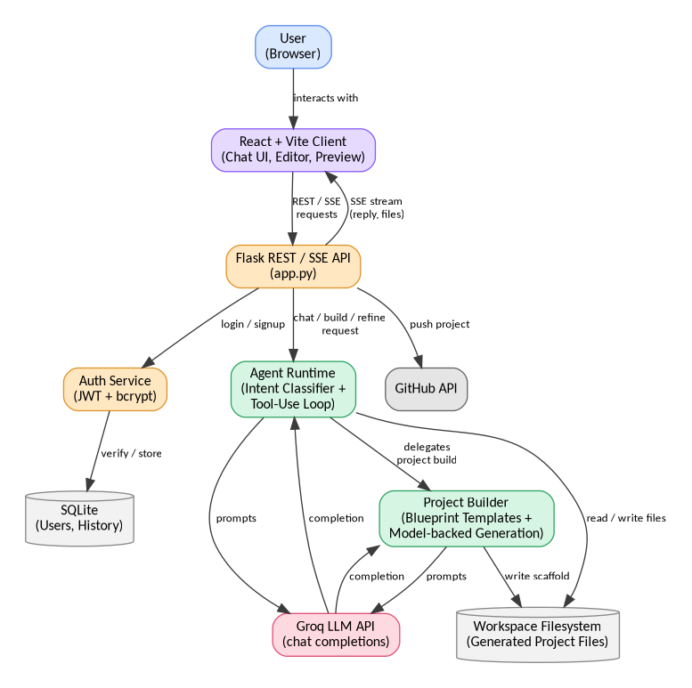
Figure 3.1: System architecture of Aizen
DFD Level 0 (Context Diagram)
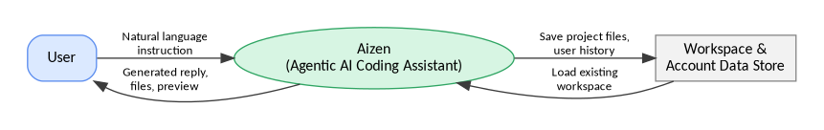
Figure 3.2: DFD Level 0 – context diagram
DFD Level 1
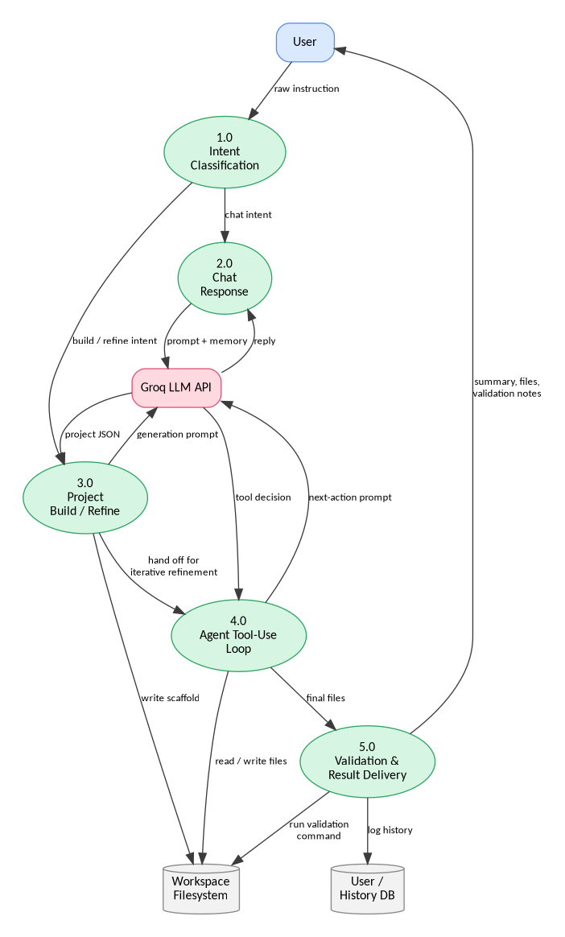
Figure 3.3: DFD Level 1 – detailed process breakdown
Use Case Diagram
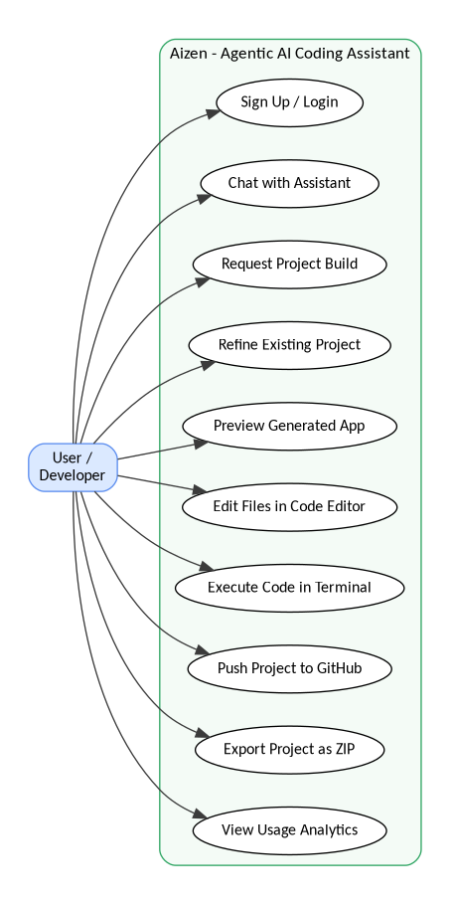
Figure 3.4: Use case diagram – Aizen

CHAPTER IV
SYSTEM REQUIREMENTS
4.1 Software Requirements
Table 4.1: Software requirements
Operating System | Windows / Linux / macOS
Frontend | React 19, Vite 6, Node.js 18+, Tailwind CSS v4
Backend | Python 3.10+, Flask 3.x, Flask-CORS
AI Integration | Groq chat-completions API
Database | SQLite
Authentication | PyJWT, Werkzeug (bcrypt hashing)
IDE / Tools | Visual Studio Code, Git / GitHub
Browser (Client) | Chrome / Edge / Firefox (latest versions)
4.2 Hardware Requirements
For Client (User side):
Table 4.2: Client-side hardware requirements
Processor | Intel i3 or above (or equivalent AMD)
RAM | Minimum 4 GB (8 GB recommended)
Storage | 200 MB free space for cache / browser storage
Internet | Stable connection (2 Mbps or above)
For Backend Server (local Flask process):
Table 4.3: Server-side hardware requirements
Processor | Intel i5 or higher (or equivalent)
RAM | 8 GB or above
Storage | 1 GB minimum for workspaces and dependencies
Network | Outbound HTTPS access to the Groq API

CHAPTER V
EXPECTED OUTCOMES…(WITH GUI)
This chapter walks through the interface as currently implemented. The figures below are placeholders marked for the corresponding screenshot of the running application and should be replaced with the latest capture before the report is finally printed or submitted.
5.1 Landing Page
The landing page introduces Aizen, states what it does in one line, and offers a direct path into the chat workspace or a short product tour.
[ Insert screenshot: Aizen landing page ]
Figure 5.1: Aizen landing page
5.2 Sign-up / Login Interface
New users can create an account or sign in with an existing one; the session is then carried by a JWT stored on the client, which is what lets the sidebar show a user's own chat history on return visits.
[ Insert screenshot: Sign-up / login screen ]
Figure 5.2: Sign-up / login interface
5.3 Chat-Based Build Workspace
The main workspace shows the running conversation on the left and, once a project exists, the generated files, live preview, code editor, search and terminal panels on the right. A user can keep talking to the agent in the same thread to ask for changes, and the agent applies them to the same workspace instead of starting over.
[ Insert screenshot: Chat + build workspace with generated files ]
Figure 5.3: Chat-based build workspace
5.4 Live Code Editor and Preview
Generated files can be opened directly in an in-browser Monaco editor, edited, and saved back into the workspace; HTML-renderable projects also show an instant preview in an adjacent pane.
[ Insert screenshot: Code editor and live preview panel ]
Figure 5.4: Code editor and live preview
5.5 Analytics Dashboard
A simple analytics view summarises how many projects and files a user has generated and the mix of languages used, mainly as a way to see how the tool is actually being used over time.
[ Insert screenshot: Analytics dashboard ]
Figure 5.5: Analytics dashboard
5.6 SQL Assistant Panel
A dedicated panel lets the user optionally describe a table schema, choose a target SQL dialect, and ask a question in plain English; the panel returns a syntax-highlighted SQL query along with a short explanation of what it does. The panel follows the same design language as the other tool panels and is opened from the same toolbar.
[ Insert screenshot: SQL Assistant panel — English-to-SQL generation ]
Figure 5.6: SQL Assistant panel

CHAPTER VI
CONCLUSION & FUTURE SCOPE
6.1 Conclusion
This project took the agentic-AI concept from our minor project, which was largely diagrammatic, and turned it into a working system in a domain narrow enough to be judged on whether it actually works: generating and maintaining software projects from a single instruction. Building Aizen end to end surfaced problems that never came up while the idea was still on paper. The most instructive one was a period during which the assistant kept returning the same generic starter project regardless of what was asked, caused by two compounding issues, an intent classifier that missed some valid build phrasings, and a language-model call that was silently failing and falling back to a template without logging why. Neither problem was visible from the outside until the failure was reproduced and the exception handling was made to actually report what had gone wrong instead of swallowing it. Fixing this taught us more about designing dependable agent systems than the original design phase did: an agent that fails silently is, from the user's point of view, indistinguishable from one that never worked, so visible failure handling turned out to matter as much as the planning and generation logic itself.
Overall, the project meets the objectives set out in Chapter I: instruction classification, multi-stack project generation with a working fallback path, an iterative agent loop, and an integrated browser-based environment for editing, running and shipping the result. It also gives a concrete answer to the open question left by the minor project, that an agentic, tool-using approach can be built and can hold up against real use, provided its failure paths are treated as first-class parts of the design rather than an afterthought.
6.2 Future Work
- Smarter fallback and self-healing – automatically retry with an alternate model or a narrower prompt when the primary model call fails, instead of only falling back to a static template.
- Multi-agent collaboration – split generation and validation between two cooperating agents, one that writes code and one that specifically tries to break it, before the result is shown to the user.
- Stronger execution sandboxing – run generated and user-submitted code in an isolated container rather than the host process, to reduce the risk surface of the terminal feature.
- Voice-based interaction – allow instructions to be spoken rather than typed, for a more natural interaction style.
- Team and workspace sharing – let more than one user collaborate on the same generated project in real time.
- Mobile-friendly client – a responsive or dedicated mobile interface so the assistant is not tied to a desktop browser.

CHAPTER VII
REFERENCES
[1] Yao, S., Zhao, J., Yu, D., Du, N., Shafran, I., Narasimhan, K. & Cao, Y., 2022. ReAct: Synergizing Reasoning and Acting in Language Models. arXiv preprint arXiv:2210.03629.
[2] Wei, J., Wang, X., Schuurmans, D., Bosma, M., Ichter, B., Xia, F., Chi, E., Le, Q. & Zhou, D., 2022. Chain-of-Thought Prompting Elicits Reasoning in Large Language Models. In: Advances in Neural Information Processing Systems (NeurIPS 2022).
[3] LangChain, 2024. LangChain Documentation. [online] Available at: https://python.langchain.com [Accessed 2026].
[4] Significant Gravitas, 2023. AutoGPT: An Autonomous GPT-4 Experiment. [online] Available at: https://github.com/Significant-Gravitas/AutoGPT [Accessed 2026].
[5] OpenAI, 2024. Assistants API Documentation. [online] Available at: https://platform.openai.com/docs/assistants [Accessed 2026].
[6] Microsoft, 2024. Semantic Kernel Documentation. [online] Available at: https://learn.microsoft.com/semantic-kernel [Accessed 2026].
[7] Groq Inc., 2026. Groq API Documentation. [online] Available at: https://console.groq.com/docs [Accessed 2026].
[8] Pallets Projects, 2024. Flask Documentation. [online] Available at: https://flask.palletsprojects.com [Accessed 2026].
[9] Meta Platforms Inc., 2025. React Documentation. [online] Available at: https://react.dev [Accessed 2026].
[10] Vite, 2025. Vite Documentation. [online] Available at: https://vitejs.dev [Accessed 2026].
[11] Microsoft, 2024. Monaco Editor Documentation. [online] Available at: https://microsoft.github.io/monaco-editor [Accessed 2026].

